Senior Design Team 16
BAE Systems
Pandey Santosh

Team Member: Role
Evan Rosonke: Project Lead
CJ Reitz: Test Lead
Ethan Houts: Software Lead
Thomas Kivlahan: Hardware Lead
Mensanh Namessi: Hardware Lead

Email: sdmay24-16@iastate.edu
Website: https://sdmay24-16.sd.ece.iastate.edu/
Revised: 09/07/2023 V1.01
Temperature Sensors For Veterans With Paralysis
Design Document
Executive Summary

Development Standards & Practices Used
List all standard circuit, hardware, software practices used in this project. List all the Engineering standards that apply to this project that were considered.
- We will need to use a communication standard, most likely Bluetooth
- Commenting code for the application for others to read easily
- Document hardware as it is implemented, as well as document hardware changes
- Standardize among hardware for an easier pairing of devices and one location for purchasing
Summary of Requirements
List all requirements as bullet points in brief.
- Temperature sensors that read body and air temperature
- Means of attaching the sensor to the body
- Phone application that uses data from the sensor to alert the user if the temperature is too extreme
- Data control center to store historical data

Applicable Courses from Iowa State University Curriculum
List all Iowa State University courses whose contents were applicable to your project.
- EE285
- CPRE288
- CPRE388
- EE330

New Skills/Knowledge acquired that was not taught in courses
List all new skills/knowledge that your team acquired that was not part of your Iowa State curriculum in order to complete this project.
- Project Management
- Communication among a large team
- IOS Development

Table of Contents

1 Team 6
1.1 Team Members 6
1.2 Required Skill Sets for Your Project 6
1.3 Skill Sets Covered by the Team 6
1.4 Project Management Style Adopted by the team 6
1.5 Initial Project Management Roles 6
2 Introduction 7
2.1 Problem Statement 7
2.2 Requirements & Constraints 7
2.3 Engineering Standards 8
2.4 Intended Users and Uses 8
3 Project Plan 9
3.1 Task Decomposition 9
3.2 Project Management/Tracking Procedures 10
3.3 Project Proposed Milestones, Metrics, and Evaluation Criteria 10
3.4 Project Timeline/Schedule 12
3.5 Risks And Risk Management/Mitigation 12
3.6 Personnel Effort Requirements 14
3.7 Other Resource Requirements 14
4 Design 15
4.1 Design Content 15
4.2 Design Complexity 15
4.3 Modern Engineering Tools 16
4.4 Design Context 16
4.5 Prior Work/Solutions 17
4.6 Design Decisions 19
4.7 Proposed Design 20
4.7.1 Design 0 (Initial Design) 20
Design Visual and Description 20
Functionality 20
4.7.2 Design 1 (Design Iteration) 21
Design Visual and Description 21
Functionality 22
4.8 Technology Considerations 23
4.9 Design Analysis 23
5 Testing 23
5.1 Unit Testing 23
5.2 Interface Testing 24
5.3 Integration Testing 25
5.4 System Testing 26
5.5 Regression Testing 26
5.6 Acceptance Testing 26
5.7 Security Testing (if applicable) 26
5.8 Results 26
6 Implementation 26
7 Professionalism 27
7.1 Areas of Responsibility 27
7.2 Project Specific Professional Responsibility Areas 30
7.3 Most Applicable Professional Responsibility Area 32
8 Closing Material 35
8.1 Discussion 35
8.2 Conclusion 35
8.3 References 36
8.4 Appendices 37
8.4.1 Team Contract 37
8.4.2 Circuit Diagram 41
8.4.3 Temperature Sensor Datasheet 42
8.4.4 Raspberry Pi Pico Datasheet 43
8.4.5 Electrical Schematic 44
8.4.6 User Manual 44

List of figures/tables/symbols/definitions (This should be similar to the project plan)
Figure (1) - Table of quantifiable metrics and their quantitative number
Figure (2) - Project Plan flow chart
Figure (3) - Project timeline
Figure (4) - Project Man Hour Breakdown
Figure (5) - Design Context Chart
Figure (6) - National Weather Service Wind Chill Chart
Figure (7) - Market Research Picture Shoe Insole With Sensor
Figure (8) - System Design Concept
Figure (9) - User Interface Design Concept
Figure (10) - Areas of Responsibility With Respect to IEEE Code of Ethics
Figure (11) - Areas of Responsibility With Respect to Our Project

Team

Team Members
Evan Rosonke, Thomas Kivlahan, Ethan houts, CJ Reitz, Mensanh Namessi

Required Skill Sets for Your Project
Electronic system integration and software development. Understanding of microelectronics and their uses within temperature sensors with Bluetooth compatibility.

Skill Sets Covered by the Team
(for each skill, state which team member(s) cover it)
Project Management- Evan Rosonke
Testing- CJ Reitz, Ethan Houts
Hardware Design- Evan Rosonke, CJ Reitz, Thomas Kivlahan, Mensanh Namessi
Software Development- Ethan Houts

Project Management Style Adopted by the team
Our team is adopting a single project manager role with leaders for each division of the project, including but not limited to a software lead, a hardware lead, a test lead, and an overall project management lead.

Initial Project Management Roles
Overall Project Management - Evan Rosonke
Software Lead - Ethan Houts
Test Lead - CJ Reitz
Hardware Leads - Mensanh Namessi and Thomas Kivlahan

2 Introduction

2.1 Problem Statement
The goal of this project is to implement a series of temperature sensors to allow individuals with paralysis in the limbs to know if their body temperature is too cold or too hot in the areas without feeling. We will then use the sensors to alert the user of any abnormality in their body temperature through a phone application. The user will wear a sensor array under their feet inside their socks. The sensor array will connect to the user’s phone and the phone will make alerts (beeping and/or vibrating) when it detects a concerning temperature. There will also be an additional alert system that doesn’t require a phone. The sounds will come directly from the device to account for situations when a phone may not carry out the notifications.

2.2 Requirements & Constraints
Hardware Requirements
- The sensor shall fit comfortably inside a boot
- The sensor shall communicate via Bluetooth to a phone
- The power supply shall last 8 hours on a charge
- The moisture sensor shall alert the user when water is present on skin
Software and UI Requirements
- The user interface shall be simple
- the phone application shall have a notification sensor
- the application shall be able to be voice-activated
- The application shall have multiple warning levels (LOLO, LO, HI, HIHI)
- The LO and HI warning levels shall be user-defined within a range
- The application shall alert users when outside acceptable temperature range
- The application shall alert instructor when users temperature is outside acceptable range
- The application shall notify a user when low battery level
Aesthetic Requirements
- The sensors shall be embedded in an insole
- The insole shall be comfortable to walk on
- The insole shall not irritate the skin
- the insole shall not interfere with sweat productions
- the power supply shall attach to the leg above the boot
- There shall be a audible alert when temperature is outside of range
Performance Requirements (Data rate and frequency of data collection and upload)
- Data shall be collected from the sensors 12 times every minute or once every 5 seconds
- Data shall be sent to the phone application as it is collected

Quantifiable Metric | Number needed
Sensors | 3/leg
Data collection Rate | 12/min
Battery Life | 8+ Hours
Figure (1)

2.3 Engineering Standards
Skin Interfaced Electronics
FDA has a list of allowable chemicals that can be used in contact with the body for microelectronics
Wearable electronics (IEEE 360-2022)
Personal health devices (IEEE 11073)

2.4 Intended Users and Uses
Our project will mainly impact those with limb paralysis or loss of feeling within limps. The idea behind this is to allow these people to do the things they love without having to worry about running the risk of the body becoming too hot or too cold. One example of people would be people who go adaptive skiing and run the risk of frostbite in their toes and would not be able to feel it. This will allow them not to worry because if this were to come close to happening, they would receive an alert beforehand to know something needs to change.

3 Project Plan

3.1 Task Decomposition

Hardware
- Temperature Sensor
  - Researching functionality
  - making sure it falls within the constraints of the project
  - has Bluetooth functionality
  - connecting sensors together
  - Power sensors
  - Test that sensors work and can last long enough
- Bluetooth device
- Attachment
  - Get design specs and see if there is a preferred method of attachment
  - Figure out the best fabrics for this method of attachment
  - research how it will interfere with the body
Software
- IPhone application
  - Bluetooth communication
  - UI design
  - Back-end
  - Optional Communication to instructor’s device
  - Apple watch compatibility - tbd with pending research
- Android application
  - To be done after iOS is complete.
  - Bluetooth communication
  - UI design
  - Back-end
  - Optional Communication to instructor’s device
  - Wear-OS compatibility - tbd with pending research
- Microcontroller program
  - Bluetooth communication
  - Collect sensor signals
  - Battery percentage indicators
  - Convert signals into usable forms for transfer
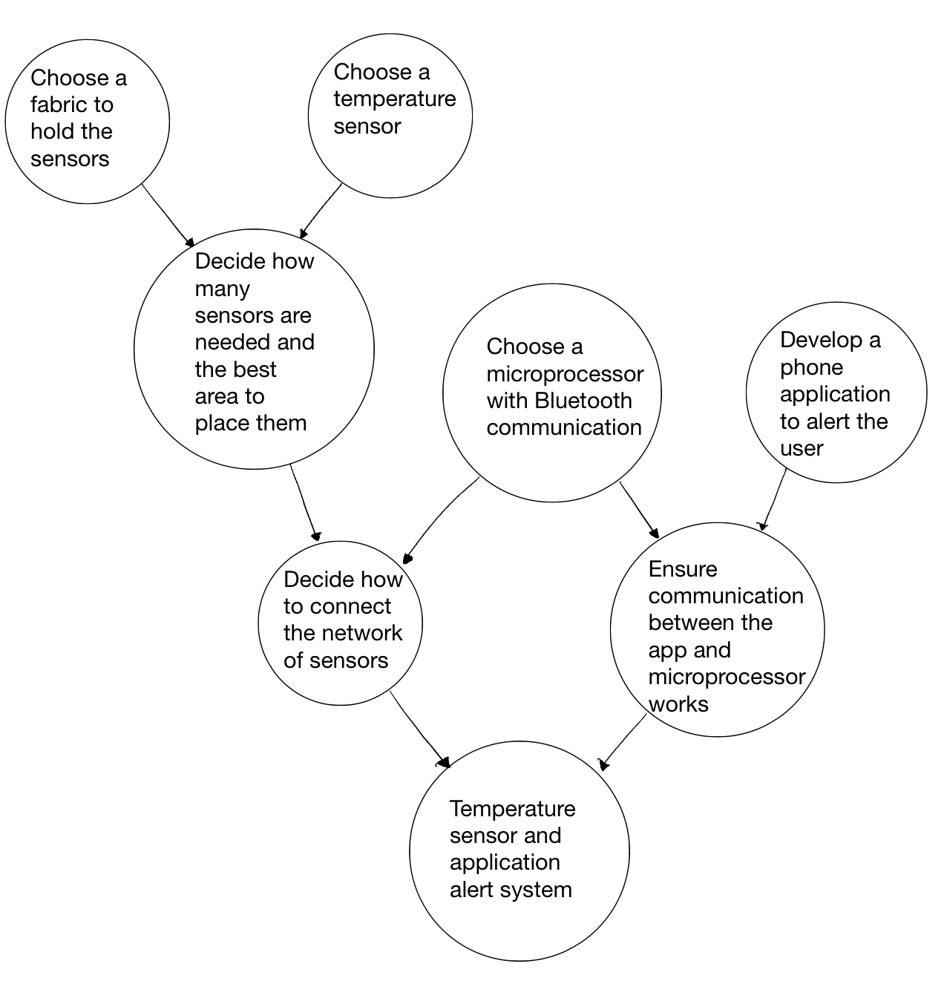
Figure (2)

3.2 Project Management/Tracking Procedures
Waterfall+agile is the best option for our team as our project consists of a software application and hardware implementation. Because both of these teams will need to be working forward simultaneously, we will work as an agile project management style between them but also try to follow a waterfall approach within each team to continue completing tasks in a forward manner.
Our team will be utilizing a combination of GitLab and Discord for project management. We will be using Discord for quick communication, meeting reminders, quick discussions, etc. We will be using GitLab to delegate tasks to individual team members as well as track progress.

3.3 Project Proposed Milestones, Metrics, and Evaluation Criteria
Hardware
- Get a list of design specs.
  - What are the functionalities they want?
  - What are our constraints?
- Start researching hardware components that fall within these constraints
  - Temp Sensor with Bluetooth transmitter
  - Data collection and control board.
  - Wire to string together sensors
  - Power supply/battery pack with recharging capability
  - enclosures for hardware that needs it and ways to attach to body the parts that need it
- Start designing layout
  - integrate sensors together
  - connect sensors to the power supply
  - connect to the data control board or application
  - make sure everything will work together
    - power consumption
    - aesthetics (not too large and easily maneuverable).
    - The components are all within the standard of skin interfaced electronics
- Order hardware components, enclosures, and fabric once research and design are complete.
- Start integrating sensors together and creating the circuit for all sensors and power supply.
- Test the functionality and power of the system.
Software
- Start development for iOS
  - UI development
  - backend development
- Create a round trip connection from microcontroller to phone
  - create basic program on chosen microcontroller to create a data transfer
  - implement integration for bluetooth on app
- Capture sensor data
  - implement sensor data collection on microcontroller
  - implement ui functionality to display recorded sensor data
- Communication functionality
  - some form of messaging to another nearby device
- Create Android version
  - Do 1-4 with the relevant portions for android development
- Watch OS companion app
  - A version of the app that has another way to alert the user
- Wear OS companion app
  - same as Watch OS but for android
Combined - After completing hardware and software pieces individually
- test that the sensors are reading data over Bluetooth
- calibrate the sensors
- check for errors in hardware or software
- fix the issues
- repeat until correctly functioning project

3.4 Project Timeline/Schedule

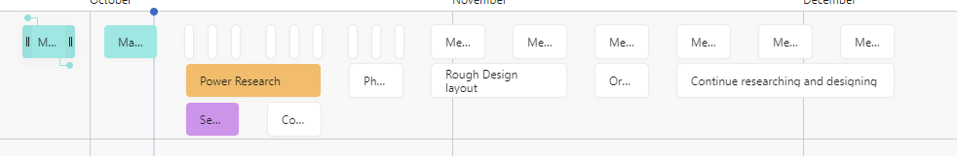
First Semester
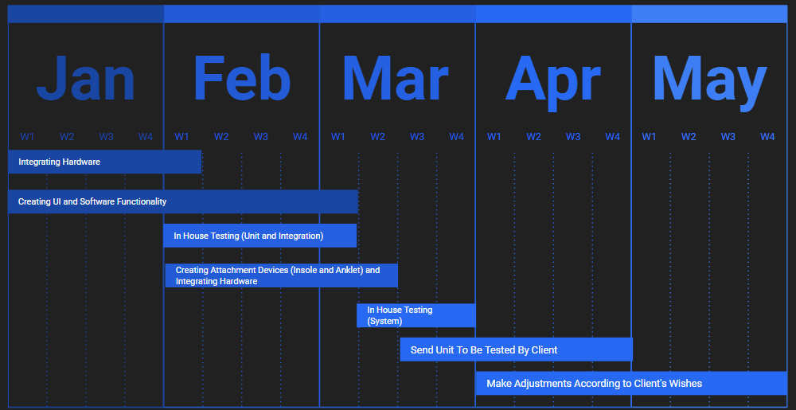
Second Semester
Figure (3)

3.5 Risks And Risk Management/Mitigation
Hardware
- Temperature Sensor
  - Researching functionality .2
  - Making sure it falls within the constraints of the project .4
  - has Bluetooth functionality .3
  - connecting sensors together .6
  - Power sensors .3
  - Test that sensors work and can last long enough .3
- Attachment
  - Figure out the best fabrics for this method of attachment .3
  - research how it will interfere with the body .2
Software
- IPhone application
  - Bluetooth communication
  - UI design
  - Back-end
  - Communication to instructor’s device
  - Apple watch compatibility - tbd with pending research
- Android application
  - To be done after iOS is complete.
  - Bluetooth communication
  - UI design
  - Back-end
  - Wear-OS compatibility - tbd with pending research
- Microcontroller program
  - Bluetooth communication
  - Collect sensor signals
  - Battery percentage indicators
  - Convert signals into usable forms for transfer
Risk Mitigation Plan
Hardware:
When connecting the sensors together there is a risk that there are issues with the accuracy or the ability to record the data. To mitigate this risk we will have multiple different sensors so that we are able to compare which sensors actually work best together. We also will all individually and collaboratively test the sensors on our own so there is a better chance that we will find a solution to the problem. We also run the risk of connectivity issues anywhere in our system, the best way to mitigate this risk will be to solder any components that can be and implement connectors that work well together.
Software:
We will also inevitably have errors in our software functions when writing them, the best way to mitigate the risk of this coming out in our final design is by testing our function in various environments

3.6 Personnel Effort Requirements
Overall, this project should count for roughly 340 total man-hours of meetings, which will be conducted on Mondays for 30 minutes, Wednesdays for 1 hour, and Fridays for 1 hour with our TA, Faculty Mentor, and Client, respectively. In these meetings, we will be discussing our weekly milestones
This project will also consist of hardware and software research, design, implementation, and testing. We estimate this will take roughly 480 total man hours averaging 20 man hours per week, roughly 4 man hours per person per week.
Research should take us around 4 weeks to complete thoroughly to where we are able to make decisions on the specifics such as what sensors and microprocessor to use which comes out to about 80 man-hours for research.
Designing should take us around 6 weeks to complete to the point where we have a very solid idea of what the final product will look like with more specific constraints. This comes out to around 120 man-hours.
Implementation and testing will go hand in hand for the most part because as we are able to implement our design, we will need to test the results to ensure that they are staying within our requirements and no problems arise. These together should take about 14 weeks, which is around 280 man-hours.
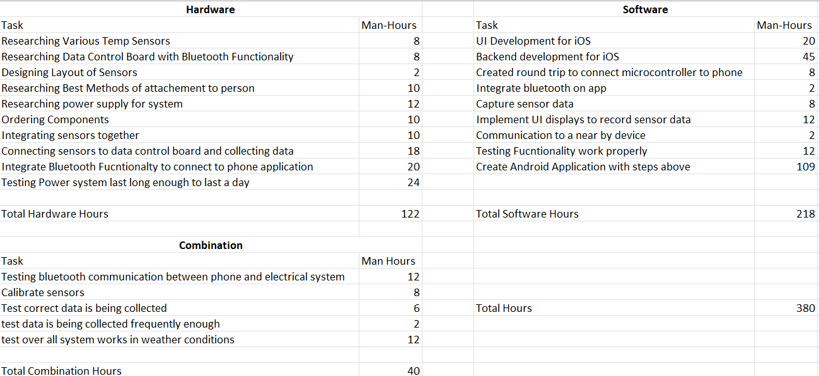
Figure (4)

3.7 Other Resource Requirements
- Software to develop an application
- Temp Sensor with Bluetooth capability
- Wiring to string together sensors
- Rechargeable battery pack to provide power
- charger for the rechargeable battery pack
- Cloth or strap to attach to the body

4 Design

4.1 Design Content
The aspect of this project that requires design will be broken up into hardware and software.
Hardware
- We will need to design a high-level layout of the sensors, power supply, and control board of how it interfaces with the body
- we will have to potentially design a microcontroller chip
- We will have to design a way to attach this system to the body including the sensors and the power supply and control board.
Software
- UI screens will need to be designed and created to be user-friendly
- We will have to design a notification center that can show up on the home screen of the phone
- We will have to complete the software design as it pertains to data collection of the electrical system

4.2 Design Complexity
1. The design is composed of multiple components that each make use of scientific/mathematical/engineering principles. The temperature sensors use the fact that voltage across a PN junction is dependent on the ambient temperature. The communication between the sensors and the user’s phone is done with Bluetooth. Bluetooth has applications in audio streaming, data transfer, device networks, and more.
2. The scope of the problem has multiple requirements that currently don’t have standard industry solutions. The goal of the project is to greatly reduce the probability of someone getting frostbite or other temperature-related problems despite having limited or no feeling in one’s feet/toes. This goal would have to be accomplished in cold conditions while the user is skiing or enjoying some other outdoor activity in the winter.

4.3 Modern Engineering Tools
Several modern engineering tools are being used for this design and more will be used. Several types of CAD softwares have been used so far with more to come. Some examples of these include AutoCAD and KiCad. AutoCAD is a software used to make technical drawings in both 2D or 3D. It will be very useful when designing enclosures for electronic components. KiCAD will be used to design PCBs. Some other tools include MATLAB and SPICE simulations. SPICE simulations will be very useful when designing circuits.

4.4 Design Context
The primary community for whom the project is intended to help is the handicapped veteran community; more specifically, those veterans who suffer from paralysis. The project has the potential to make outdoor winter activities safer without taking away from the experience. Taking care of the veterans is always a societal need and this project can contribute to the quality of their lives.

Area | Description | Examples
Public health, safety, and welfare | This project makes skiing and other outdoor activities safer for those with limited nerve function in their lower extremities. | Someone with the inability to feel the sensation of cold in their feet becomes way more vulnerable to frostbite and hypothermia. A warning system can give these individuals a chance to find warmth before suffering permanent damage to their bodies.
Global, cultural, and social | The project is definitely aligned with the values of the handicapped veteran community. Although being a veteran is not an ideology, it can be safely assumed that they want the best for each other and providing tools that allow them to enjoy more experiences will undoubtedly receive support. | The project can lead to a more diverse skiing clientele. It can also lead to more awareness of pastimes that have been unavailable to persons with paralysis in the past.
Environmental | It’s hard to imagine this project having any substantial environmental impact. There’s always a carbon footprint associated with the production of anything but it will be negligible in the big picture. | The biggest potential environmental impact from the project comes from the use of disposable batteries. The proper disposal of those will be the responsibility of the consumer.
Economic | This product has the potential to increase the number of customers in ski resorts and other cold outdoor activities. This can lead to increased revenue at those resorts and increase the demand for ski gear also. | There is no reason that the end product should be unaffordable. It uses materials and components that are commonly used in other applications.
Figure (5)

4.5 Prior Work/Solutions
There have not been any widely published attempts to provide a warning about concerning temperatures in areas of one’s body for those with limited or no nerve sensation. Because of this, this project will require research about frostbite in all patients. Below is a chart made by the National Weather Service that can give a baseline for temperatures that warrant a warning.
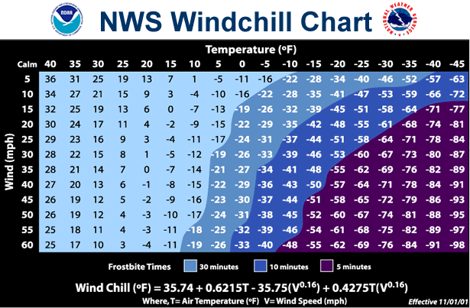
Source: https://www.weather.gov/bou/windchill
Figure (6)
As far as similar products go, there are a few examples of devices with a similar build. One example is the CARV. It is a device that goes in one’s ski boot to monitor pressure points so that the skier can get feedback on his/her technique.
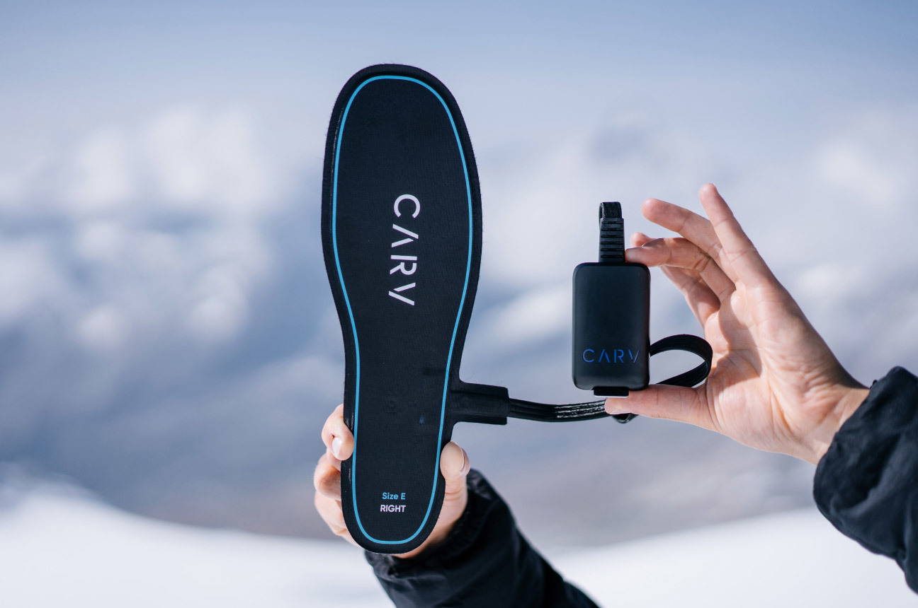
Source:https://proskaters place.com/shop/winter-sports/carv-digital-ski-coach/
Figure (7)
This product can set a precedent for durability and it shows that there have been other electronic insoles that have been successfully implemented in the past. This is not in any way potential competition for the project’s final product because it does not monitor temperature and it’s only used by those with full use of their feet.

4.6 Design Decisions
One key design decision we have made is how to attach the system to the body to make it the most comfortable, agile, durable, and easily usable. Our initial thought was to use a sock-like feature, but the client let us know there had been previous groups that had tried this and had issues with the sock falling off the foot and bunching up, as it is not a one-size-fits-all. We have since switched to a gel insole-like feature that will fit inside a person's sock and will attach directly to the skin, and get a better temperature reading. There will be multiple sensors in the insole to read temp at various locations on the foot.
Another key design feature we are working on is an attachment of the power supply, control board, and Bluetooth transmitter to the person. Again we had an initial thought which has since changed once we did our detailed initial design. Our initial thought was to have the wires run up the leg to a small box that would fit inside the pocket. We have since changed our mind due to loss of power over long wires and decided to run the wires just above the boot and attach all of the control and power in a small enclosure to the leg using a velcro strap.
Our third key design decision includes our software/UI. With our system having two levels of alarms such as a warning level and a critical warning level, we have decided to allow the user to define a specific temperature for the warning level so they can adjust the amount of time they need to get inside or find a way to warm their extremities based on current weather conditions, their mobility, and their preference.

4.7 Proposed Design
So far, we have a systems design drawn up and have started implementing small portions of our UI and phone application. Our overall system design consists of multiple sensors in a shoe insole-type layer. The sensors embedded are primarily temperature sensors with the possibility of adding moisture sensors. These then run up to an ankle bracelet attached by a velcro strap. The anklet has a power supply and a control chip for Bluetooth.

4.7.1 Design 0 (Initial Design)

Design Visual and Description
Our design is broken into hardware and software components.

The hardware consists of two main areas: the control and power box and a sock-like feature containing temperature sensors. The power and control box consists of a power supply to our sensors, microchip, and Bluetooth chip that relays the data to the phone application. This will run up the leg and be able to go inside the pocket of the pants. The second part is the sock-like feature, which will slide onto the leg and have a layer of sensors that will run through wires to the control box.

The software side of things consists of two main portions: user interface and logic. On the logic side of things, the main focus is paying attention to the proper parameters ie. temperature, and making sure we can warn people if their body temperature is getting to a dangerous level. From there we will look at the user interface, which will show the warnings and current temperature and be easy to use.

Functionality
Our design is intended to be as simple as possible. We use a sock-like feature that will read in body temp and be sent to a control box that is in the pocket of the user. We will run wires to a small yet effective control and power box that fits inside the user's pocket. The person will then be able to connect to the sensor system via Bluetooth using their phone. This will have a simple user interface that will show warnings and body temperature.

4.7.2 Design 1 (Design Iteration)

Design Visual and Description
Our design is broken out into hardware components and software components.
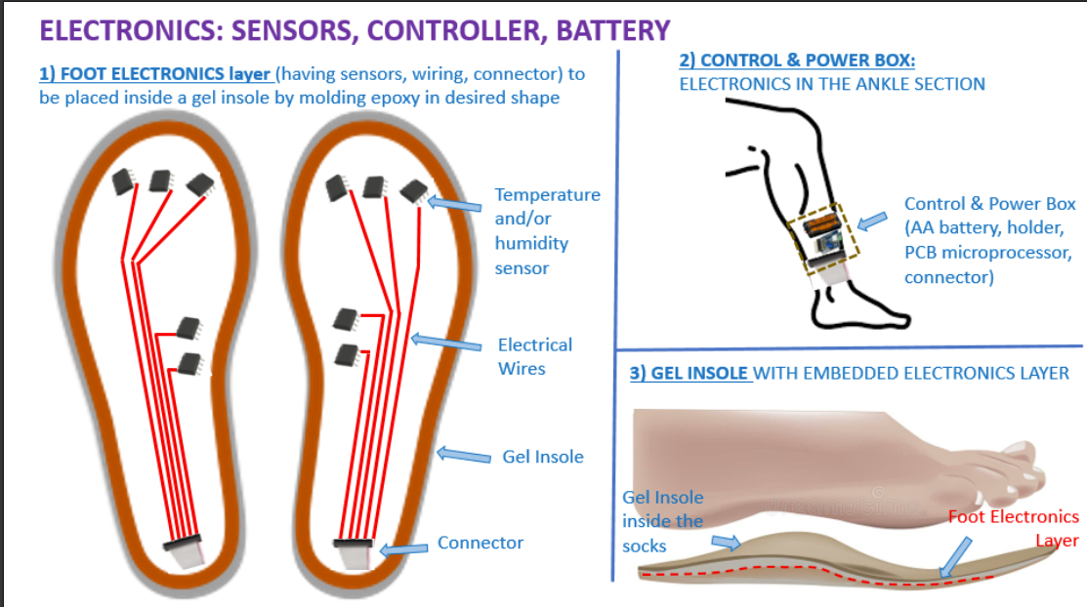
Figure (8)

The hardware consists of two main areas: the control and power box and the shoe insole with an embedded electronics layer. The power and control box consists of a power supply to our sensors and microchip, as well as the microchip and Bluetooth chip that relays the data to the phone application. This will be attached to the person's lower leg via a velcro strap. The second part is the foot electronics layer and gel insole. The gel insole contains sensors, mainly temperature sensors, but also a potential for moisture sensors. This insole will go inside the sock and attach to the bottom of the foot to read the data. There will then be wires running toward a connector where all sensors are connected to a ribbon cable that runs to the control box.
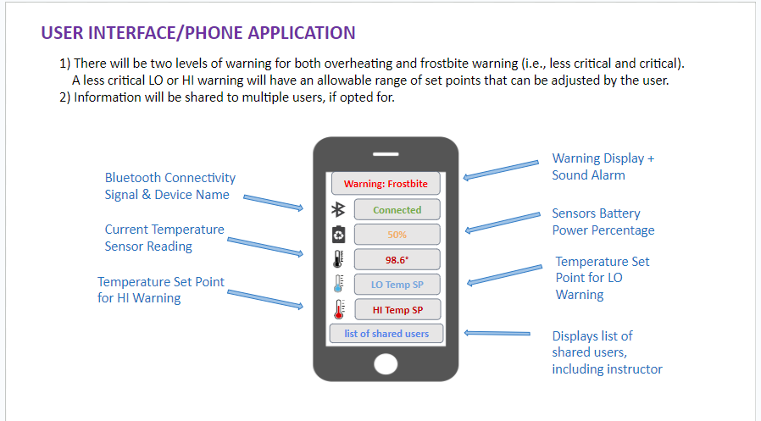
Figure (9)
The software side of things consists of two main portions, user interface and logic. On the logic side of things, the main focus is paying attention to the proper parameters ie. temperature and making sure we can warn the people if their body temperature is getting to a dangerous level. From there, we have decided to implement two levels of warnings, one being a low-level warning and the other being a critical warning. The less critical level of warning is going to have an allowable range of set points for the user to define if they want a longer time before they need to get attention or if they are fine with a shorter time. On the other side of things the biggest goal with the user interface is simple yet effective. We are going to have the basic functionalities shown above which include the requirements of Bluetooth connectivity, HI and LO user-defined temp setpoints, a notification center, and the battery life of the system. as well as showing the current temperature being read in by the sensors.

Functionality
Our design is intended to be as simple as possible. We are using a shoe insole-like feature with temperature sensors to read body temperature. From here we will run wires to a small yet effective control and power box that attaches simply to the ankle and fits inside the pants without compromising the warmth of the pants. The sensors will read the data transmitting it over Bluetooth to the phone application. In the phone application, there will be logic running in the background that compares the data being read to set points for hypothermia warning and frostbite warnings that make sure the user is not at a critical level for any of those conditions. There will be two levels of warning and the lower level of warning will be allowed to be set by the user in the application within an allowable range. If this set point is hit they will receive a notification saying they need to do something differently. Once they hit the second warning level, they have very short time before either hypothermia or frostbite is setting in. We currently do not have anything implemented.

4.8 Technology Considerations
Currently, we are trying out various temperature sensors to figure out which one will work the best without consuming too much power.
One common thing with all our sensors is their range is very plentiful, running from roughly -40 degrees C up to 120 degrees C, which will be plenty of temp range for our application. One of the sensors also has an added humidity sensor, which would be an added benefit in the case of snow or water getting onto the skin, which can force frostbite to set in more quickly.
We are currently using a Raspberry Pi Pico as our microcontroller, which will handle our Bluetooth functionality and for the ADC to read in sensor data. Another thing we have considered using is creating our microcontroller with more ADC and Bluetooth functionality. Currently, the Pico has enough functionality for what we need without consuming too much power. One thing with the Pico is there are only three ADCs on it, and in our original design, we hoped to have 5 sensors per foot. If we were to create our microcontroller, we could add more ADCs to allow for more sensors.

4.9 Design Analysis
We have started implementing both hardware and software aspects separately, each aspect of the design seems to be functioning properly in the intended use. We still have plenty of implementation yet to do and will continue making adjustments as needed as we move into the next semester.

5 Testing

5.1 Unit Testing
We have two sections of Unit Testing, Hardware and Software:
Hardware
- Sensor
  - Power
    - can be powered via the Raspberry Pi Pico which comes from the AA batteries
  - Connectivity
    - connected via wire to and are getting a connection from the sensor to the Pico, can be tested via electrical meter
  - Reads in data
    - show up on Raspberry Pi Pico as any value
  - Reads in correct data
    - show up on Raspberry Pi Pico as the correct value validated by temp controlled environment and back up sensor that has been previously calibrated.
- Pico
  - Is being powered
    - Plan to power with 2 double A batteries, make sure it can turn on when connected
    - When powered by battery the Pico can operate for 6-8 hours
  - Can connect to phone application Via Bluetooth
    - phone is connected to Pico, show by a connection status
Software
- Warnings
  - Less critical warning levels are able to be set
    - warnings will change as they are set in user interface
  - More critical warnings are hard set
    - will test when temp is read in that the warning show up on user interface at correct temp
- Bluetooth
  - Bluetooth is usable with sensors and connected
    - Bluetooth will be able to be shown as connected
    - sensors will read in data able to be utilized via software
    - can be connected by 2 people (user and instructor)

5.2 Interface Testing

- Phone Application/User Interface
  - Bluetooth Device
    - Pico is connected to the phone application, status is shown on screen
    - can allow up to two people to connect to the same device (for user and instructor)
  - Sensor
    - Temperatures are being read into the phone application and shown on screen and correct
  - Battery Life
    - battery life is shown on the screen and correct, will test through various length of having the power on to see how long it lasts
  - Warnings
    - warnings are shown on screen when get to the correct level, will test by introducing to cold and making sure the warning is going off.
- Attachment to body
  - Insole can fit inside many size socks
    - will test that it fits in various sizes
  - wires can run long enough to make it to the anklet
    - will make sure it can run above a typical ski boot
  - anklet can be comfortably connected
    - will test by wearing it around

5.3 Integration Testing
There are three main parts for integration testing.
- One is the collection of all the sensor data
  - There will be multiple sensors in which we need data collection from every sensor individually
    - Should be reading data into the phone application and dashboard from 6 total sensors
  - There will also be two sensor systems on each person (one for each leg) which will need to be integrated together into one phone application
    - Should have information from 6 sensors and capability to connect to two Raspberry Pi Picos from one phone
- Sending the information to the phone over the Bluetooth connection
  - with the phone application the information from the sensors should be sent via Bluetooth to the phone application
    - this will be tested by connecting the phone to the Pico and being able to read in the data from the correct sensors
- Various functions of the application itself.
  - On the software side of things there are multiple layers of functions that will need to be integrated together in order to make sure they work together without ruining other functions. Some of these functions include
    - Warnings when the temperature is below the setpoint
    - User interaction functionality
      - warnings
      - connecting to the system
      - digital reading of temperature
      - allowing the user to set lower level setpoints
    - Bluetooth capability

5.4 System Testing
System-level testing will mainly be done when the full system with multiple sensors communicates over Bluetooth to our phone application and is calibrated correctly. Most of the individual testing will be done when the full systems come together. Once we get the full system together, we will test it by testing it out, walking around for a day, or going skiing and utilizing it in various environments, providing feedback, and making changes where necessary. We will then send our client a prototype to use as well and make changes based on feedback from our client.

5.5 Regression Testing
Once new features are added we plan on going back through our requirements list and making sure each feature on the list that we have already implemented works or needs to be updated or fixed to fit the new changes.

5.6 Acceptance Testing
Our contact at our company has given us access to two testers who are interested in using the product themselves and are our primary source of requirements. Success for us in this portion of testing is making them happy.

5.7 Security Testing (if applicable)
Security testing is not an applicable portion of our project.

5.8 Results
At our current state in the project we have been able to implement a sensor system on a breadboard that will read in 3 temperatures. We have been able to get consistent temperature readings across the three sensors that are relatively close to room temperature. We have also been able to start reading and writing value over Bluetooth with our Raspberry Pi Pico which are two major milestones for us. We will be looking to continue implementing new parts of our project as we look into next semester.

6 Implementation
Initial Implementation (First Semester)
Hardware:
The initial hardware implementation was a one-sensor and multi-sensor system using a breadboard and various temp sensors in order to figure out which sensor would work the best for our application. We are reading the data using a Raspberry Pi Pico in order to see a correct data reading.
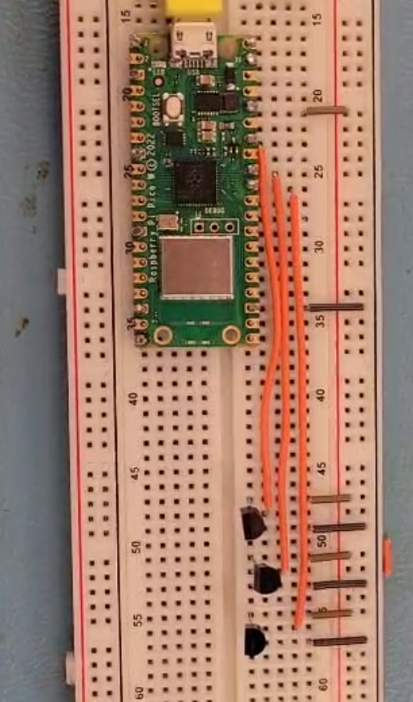
Software:
Our initial software implementation consisted of getting some of the functions working, such as Bluetooth working for iOS, and we have started creating some of our comparison functions for temperatures and setpoints. We have started creating our user interface and have certain aspects such as temperature set points, a warning center, places for temperature readings, etc.
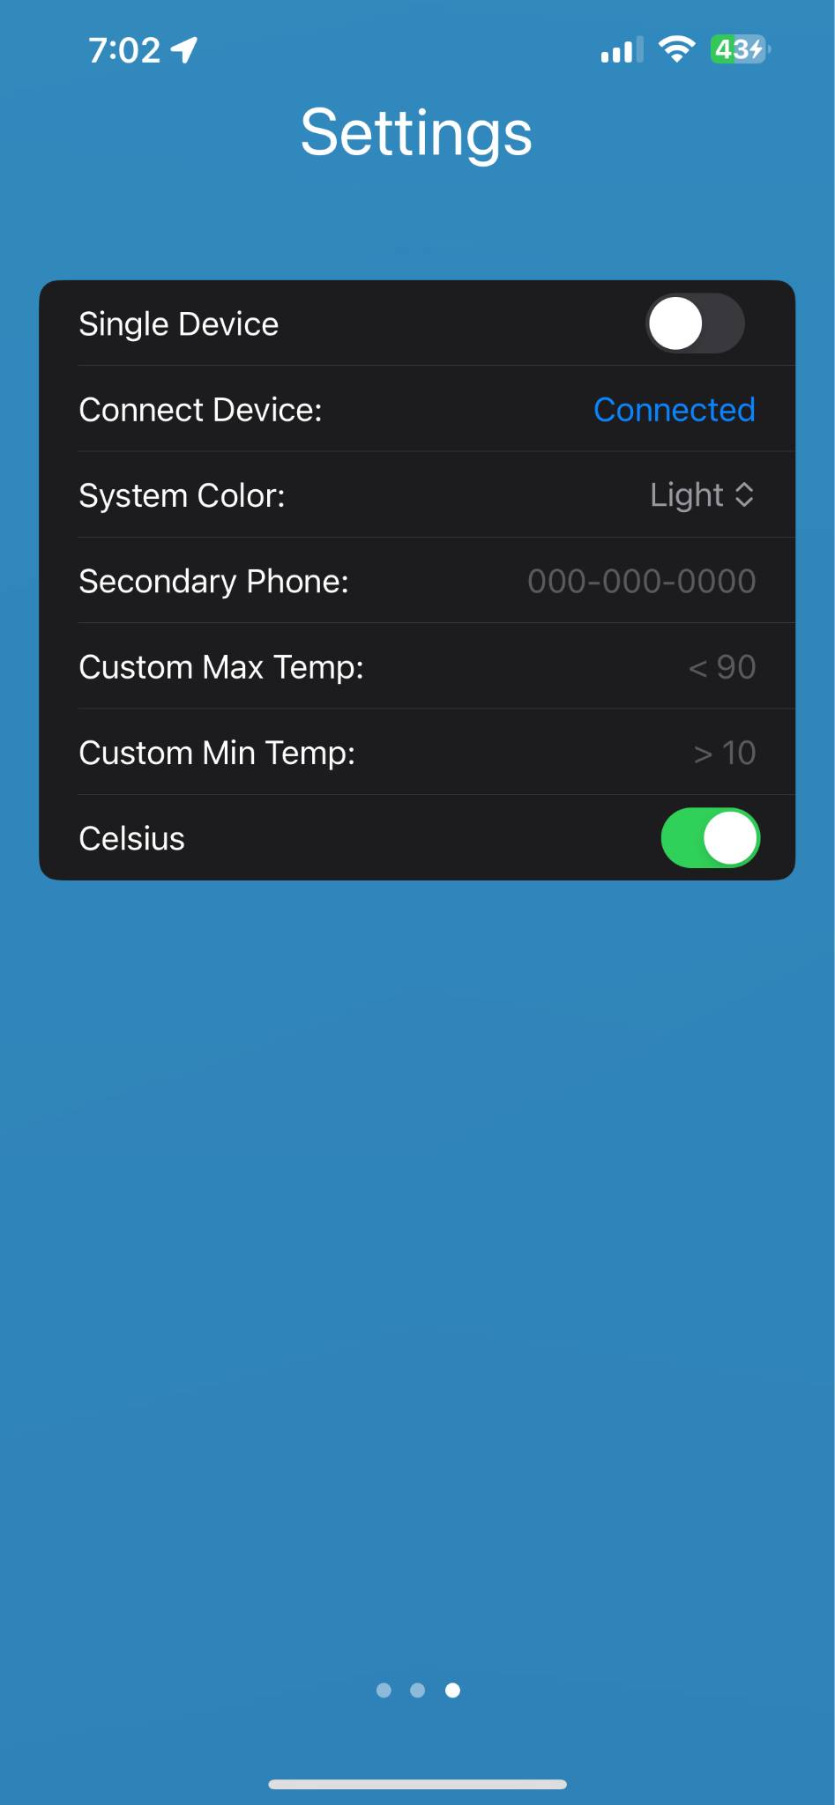
Aesthetic:
During our initial implementation, we had not yet started working on aesthetic aspects of our design, such as the insole or control box and had not been packaged into a wearable device.

Final Implementation (Second semester)
Hardware:
During the second semester, we worked to move our hardware off the breadboard and into a wearable enclosure. In doing so, we also had to convert the power source for our system from the laptop USB port to 2-AA batteries. All this is held inside a waterproof enclosure with a connector sticking out one side. This connector pairs with the other components of our hardware. The foot insole or strap. This portion of our hardware contains the temperature sensors and packages them into a wearable device to easily read the body temperature of the person's foot.
The functional hardware components are:
- 2-AA Batteries
- Raspberry Pi Pico W
- TMP 36 Temperature Sensor
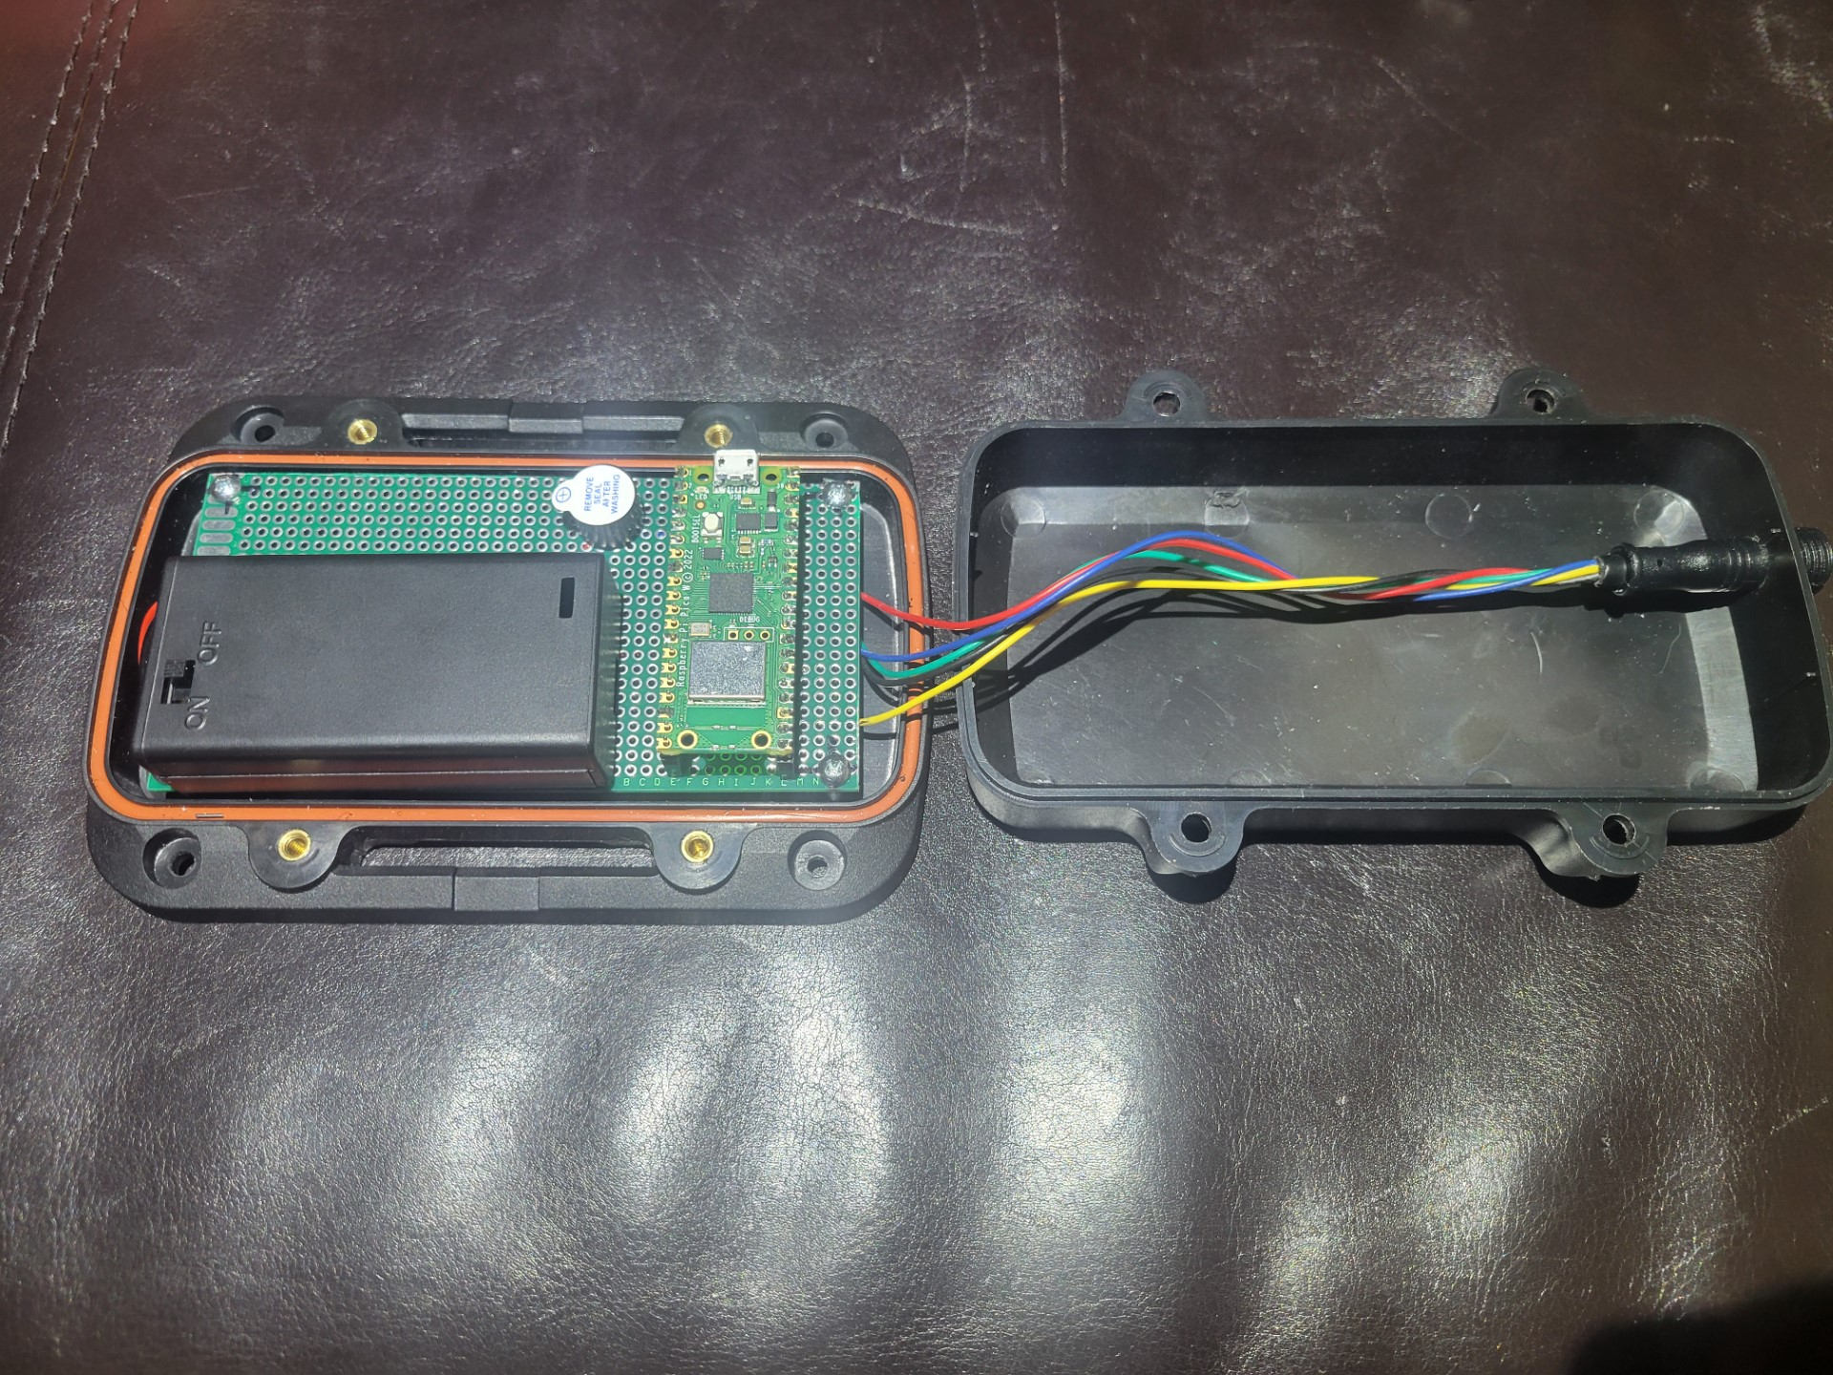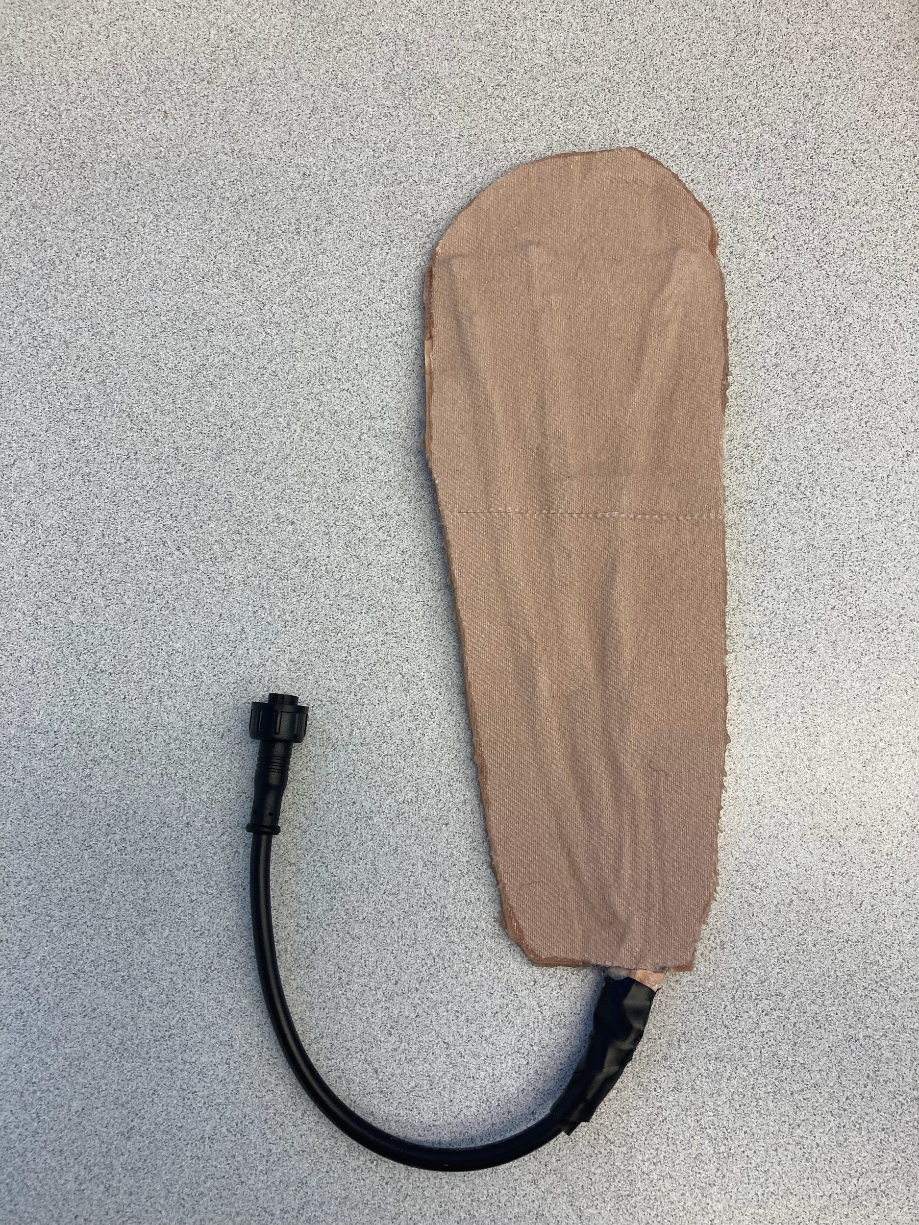
Software:
During the second semester we added to our functionality within our phone application. On top of having a notification center within the app, we have also been able to add notifications that will show up on both the lock screen and home screen if you are no longer in the app. We are also able to connect to multiple devices, such as one hardware device for each foot, and show both temperatures in the app. We also have allowed for users to define an inside limit, which will give them a longer warning depending on how long they need to seek a warmer place. we also have a trend chart within the app to see if your body temperature is rapidly increasing or decreasing. And the app can be used by anyone who needs to see temperatures in Fahrenheit and Celsius.
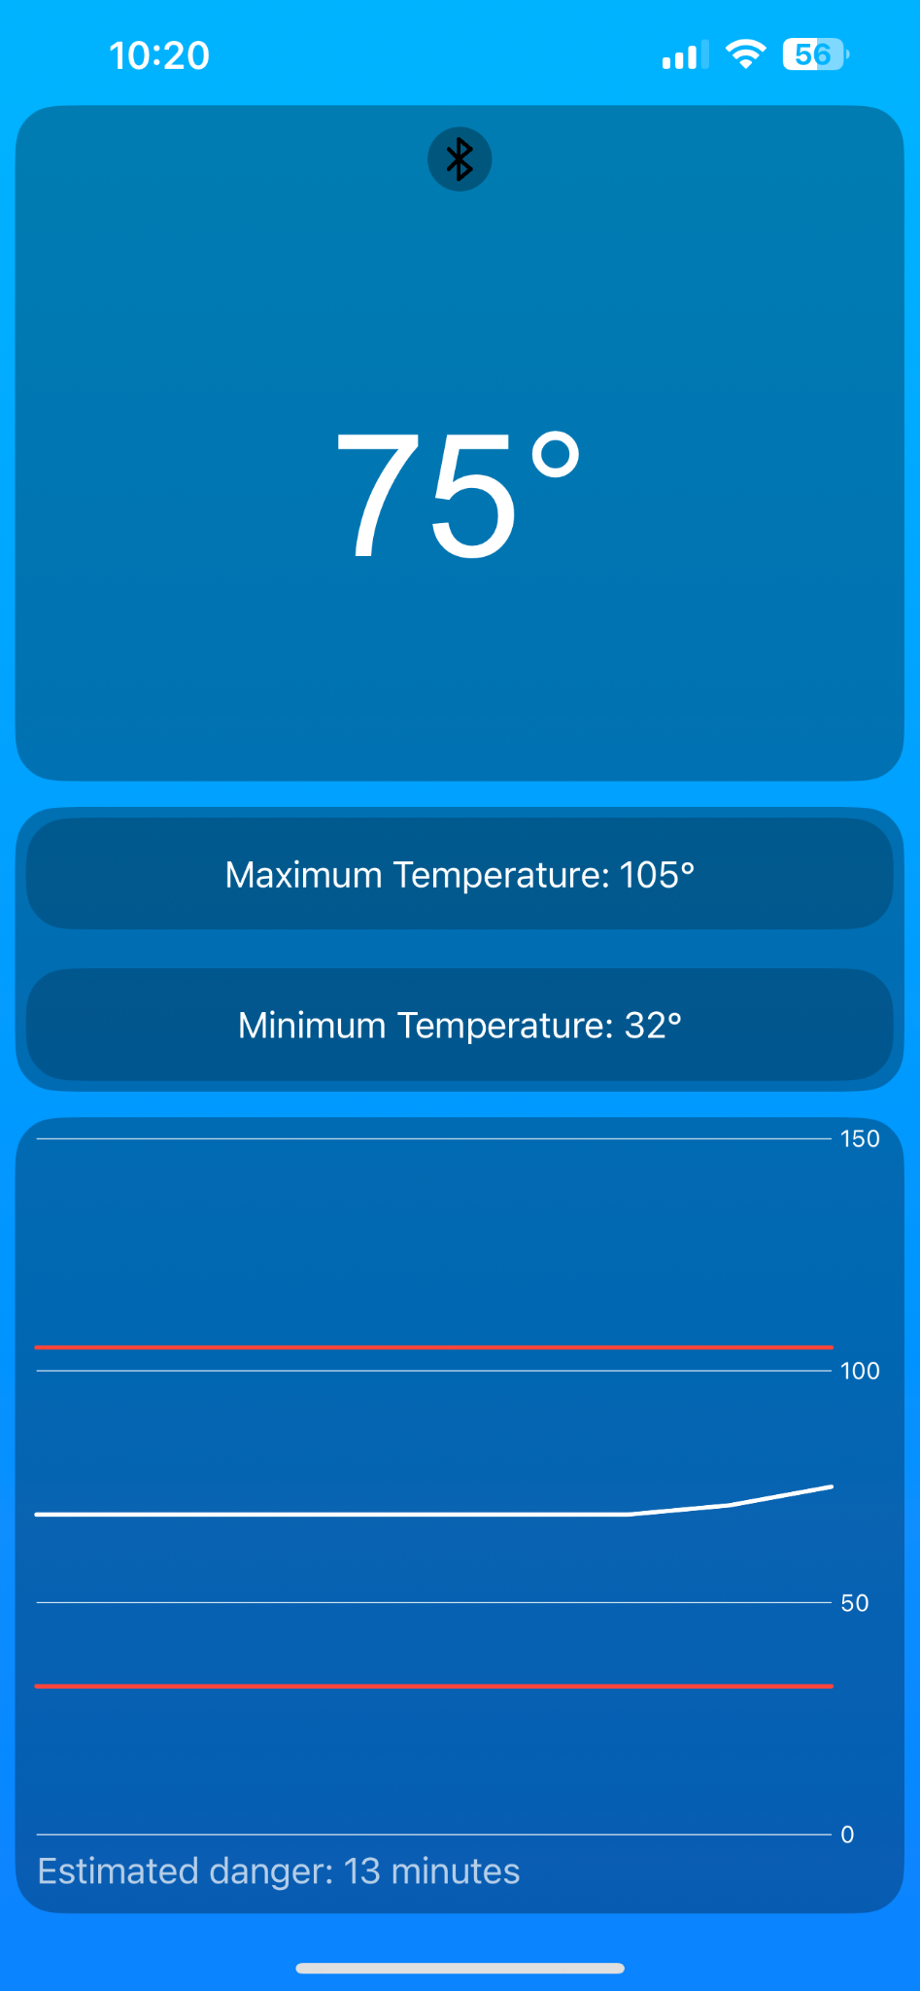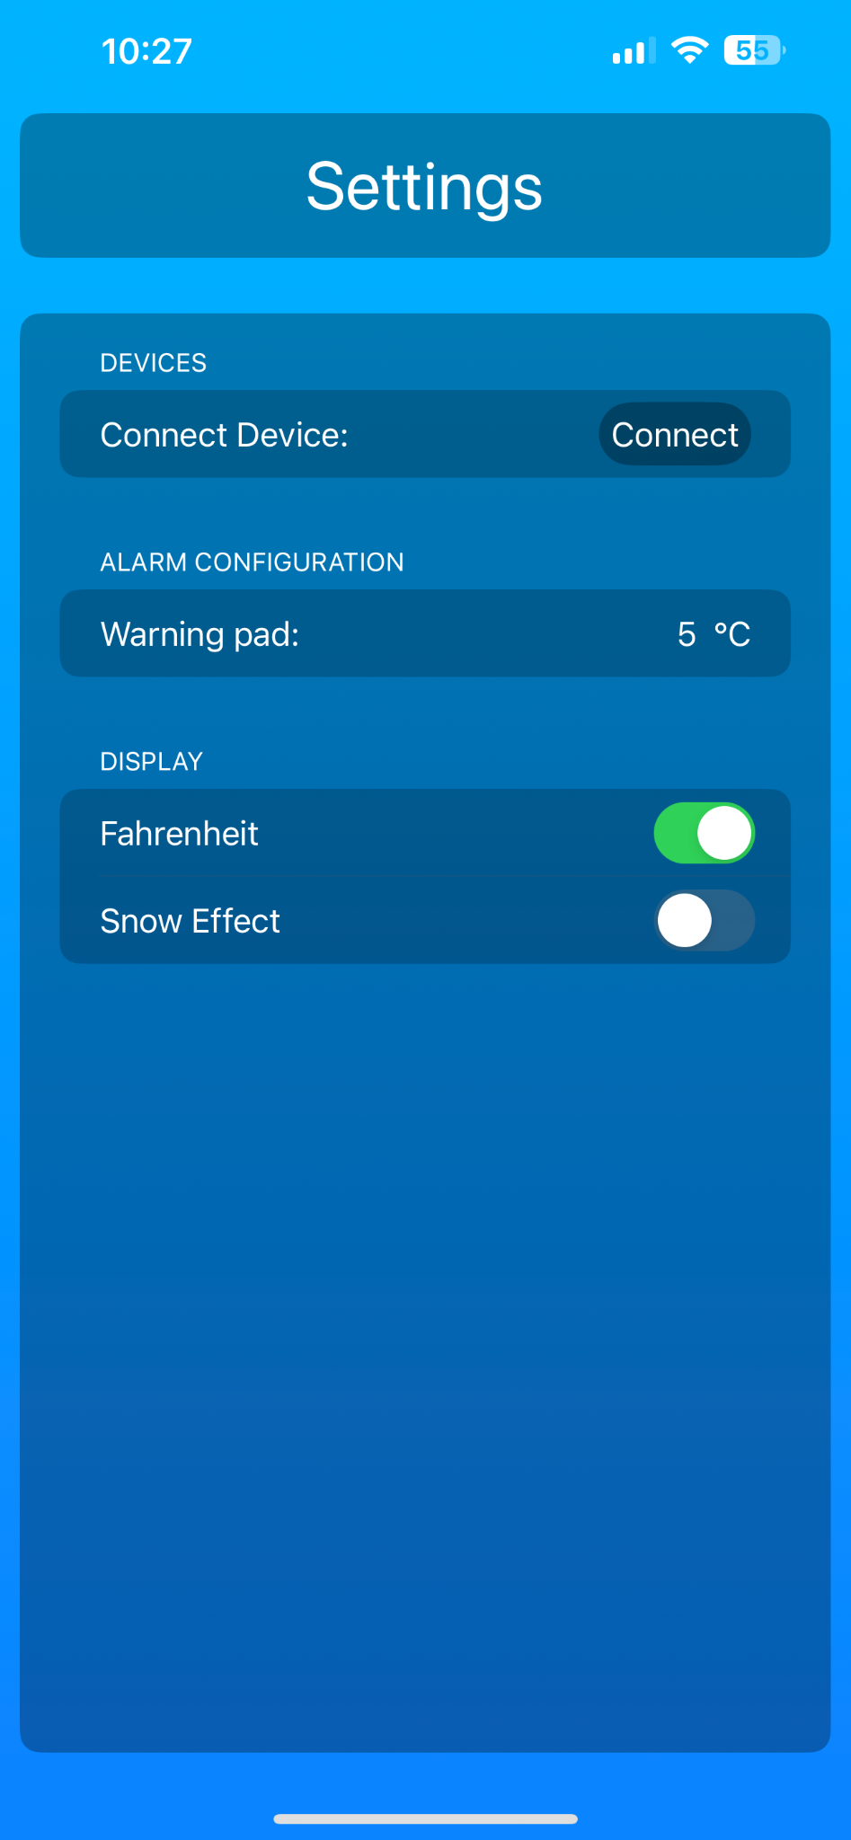

7 Professionalism

7.1 Areas of Responsibility
Table 1: Professional Responsibility Comparison - NSPE vs. IEEE Code of Ethics
Area of Responsibility | Definition | NSPE Canon | IEEE Code of Ethics | Difference from NSPE
Work Competence | Perform work of high quality, integrity, timeliness, and professional competence. | Perform services only in areas of competence; Avoid deceptive acts. | Principle 1: "to accept responsibility in making decisions consistent with the safety, health, and welfare of the public." | The IEEE pays more attention to decision-making with public safety, health, and welfare, and is taken into account more. NSPE focuses on competence and avoiding deception.
Financial Responsibility | Deliver products and services of realizable value and at reasonable costs. | Act for each employer or client as faithful agents or trustees. | Principle 6: "to maintain and improve our technical competence and to undertake technological tasks for others only if qualified by training or experience, or after full disclosure of pertinent limitations." | The IEEE focuses on the importance of maintaining and improving technical knowledge.
Communication Honesty | Reports work truthfully, without deception, and are understandable to stakeholders. | Issue public statements only in an objective and truthful manner; Avoid deceptive acts. | Principle 7: "to seek, accept, and offer honest criticism of technical work, to acknowledge and correct errors, and to properly credit the contributions of others." | The IEEE pays extra attention to seeking and offering honest criticism to be made aware of errors, and crediting contributions. The NSPE's focus is on public statements.
Health, Safety, Well-Being | Minimize risks to safety, health, and well-being of stakeholders. | Hold paramount the safety, health, and welfare of the public. | Principle 1: "to consider the safety, health, and welfare of the public, and to strive to comply with ethical design and sustainable development practices." | The IEEE adds a focus on ethical design and sustainable development practices.
Property Ownership | Respect property, ideas, and information of clients and others. | Act for each employer or client as faithful agents or trustees. | Principle 4: "to treat fairly all persons and to not engage in acts of discrimination based on race, religion, gender, disability, age, national origin, sexual orientation, gender identity, or gender expression." | The IEEE includes more about fair treatment and non-discrimination. It addresses more of a range than the NSPE.
Sustainability | Protect the environment and natural resources locally and globally. | Not explicitly mentioned, but aligns with ethical considerations related to societal and environmental impact. | Principle 3: "to be honest and realistic in stating claims or estimates based on available data." | The IEEE shows a commitment to honesty and tries to emphasize transparency in environmental impact assessments.
Social Responsibility | Produce products and services that benefit society and communities. | Conduct themselves honorably, responsibly, ethically, and lawfully to enhance the honor, reputation, and usefulness of the profession. | Principle 7: "to seek, accept, and offer honest criticism of technical work, to acknowledge and correct errors, and to properly credit the contributions of others." | The IEEE and NSPE focus on honesty and transparency are in agreement.
Figure (10)

7.2 Project Specific Professional Responsibility Areas
Area of Responsibility | Does it Apply To Our Project, Why or Why Not
Work Competence | This does pertain to our project as we should be providing a high-quality product to our client and we do have to do it in a timely manner. We have to deliver a high-quality prototype at the latest in May but preferably before as we can then allow them to test it and provide feedback on what changes they would like to see before the end of our time working on the project.  High-We are doing our best to focus on each individual area of the product and do research in order to use the best components and make it as user-friendly as possible.
Financial Responsibility | While this does apply to our project, it is not the sole focus of our project. We are given a budget of $5000 dollars and need to stay within this budget, but our main goal is to get a high-quality functioning prototype and worry about making it cost-effective later on.  High-While this is not a top priority for the project we are coming in well under budget so far in our project, finding cost-effective ways to produce our prototype.
Communication Honesty | This does apply to our project, we have two clients who we have to report to, one is BAE Systems which is working with us on this project and mentoring us through it, and the other is Adaptive Adventures, they are the ones who are actually going to be using our device.  Medium-We have recurring meetings with both of our clients that apply to this project. We make sure to keep them updated on progress and ask if there are any changes they would like to see to our current prototype, there is always room for better and more communication with the clients.
Health Safety and Well-Being | This does play a factor in our project as the goal of this is to improve the lives of people with paralysis. With creating a device like this, there can be a lot of complications such as skin irritation which we need to avoid for the sake of comfort, health, and safety of the user.  Low- As we have not yet started implementing the part of the project that will connect to the person we have not had to worry about the health and safety of the user
Property Ownership | The initial concept idea was not our idea but the idea of a person who enjoys skiing and needs a device like this to monitor the temperature in the paralyzed limbs in order to make sure they are not subjecting themselves to frostbite. The overall design had come from our team which came from the requirements that had come from our client as well as other requirements that we saw fit.  Medium-This has not been a huge aspect in our project as we are running with an idea and have not worked on protecting ours or anyones ideas.
Sustainability | The temperature sensor system does not have very many environmental effects, the only one that may play a factor would be the disposal of the AA batteries that will power the system but this could be replaced by rechargeable AA batteries.  High- Our overall system is reusable other than the power supply but this can be easily switched over to a reusable power supply if needed. That is the only aspect of our project that could run into issues when it comes to sustainability.
Social Responsibility | Our product is designed for use in a specific community, people with paralysis. It was created to benefit these people with paralysis in order to allow them to perform activities in the cold and give them a peripheral nerve system that can connect back to their phone.  Medium - While this product can help people it only helps a select group of people, in the future, there could be ways to adapt this to help a larger group of people.
Figure (11)

7.3 Most Applicable Professional Responsibility Area
We believe all of the areas are applicable to our product but one of the most applicable is the work competence. We are here to provide a high-quality system in a timely manner. All of the other responsibility areas do apply but we believe this is the most important one that pertains to our device.

8 Closing Material

8.1 Discussion
Our product is still a work in progress, but as we have been starting to implement our prototype, we are following our requirements very closely, allowing room for growth and for changes as we see fit. While there may be changes that will be made to our requirements, we will make sure that the necessary functionality is kept in our requirements such as Bluetooth compatibility, temperature sensing, and warnings. Some requirements may change or be added, such as the potential for a humidity sensor or a sounding alarm.

8.2 Conclusion
So far, we have been working with our partners at BAE Systems and Adaptive Adventures to design and implement a device that will allow people with paralysis to get warnings on a mobile application if their body temperature in those areas, without feeling, are getting too cold. The main purpose is to be used for adaptive skiers to ensure they are not getting frostbite. We have started implementing our phone application both on the user interface side and on the functionality side, such as comparing read-in temperatures to the set points. On the hardware side, we have started implementing our sensor systems just using a breadboard. We hope to continue moving forward and getting a more user-friendly system that can be used as an insole-like feature with an easily attachable control box. Our hope is to make everything simple to use, easy to attach, and as user-friendly as possible both with the hardware and the phone application.

8.3 References
References:
[1] C. C. medical professional, “Hypothermia (low body temperature),” Cleveland Clinic, https://my.clevelandclinic.org/health/diseases/21164-hypothermia-low-body-temperature (accessed Sep. 25, 2023).
[2] Raspberry pi datasheets, https://datasheets.raspberrypi.com/pico/pico-datasheet.pdf (accessed Dec. 4, 2023).
[3] “Spinal Cord Injury,” Mayo Clinic, https://www.mayoclinic.org/diseases-conditions/spinal-cord-injury/symptoms-causes/syc-20377890 (accessed Oct. 2, 2023).
[4] Low voltage temperature sensors TMP35/TMP36/TMP37, https://www.analog.com/media/en/technical-documentation/data-sheets/TMP35_36_37.pdf (accessed Dec. 4, 2023).
[5] A. Industries, “Adafruit Industries, Unique & Fun DIY electronics and kits,” adafruit industries blog RSS, https://www.adafruit.com/ (accessed Dec. 3, 2023).
[6] “Carv Digital Alpine Ski Coach with 2 Year Subscription,” ProSkaters Place Skate and Ski Shop, https://proskatersplace.com/shop/winter-sports/carv-digital-ski-coach/ (accessed Dec. 3, 2023).
[7] N. US Department of Commerce, “Wind chill safety,” National Weather Service, https://www.weather.gov/bou/windchill (accessed Dec. 3, 2023).

8.4 Appendices
We do not have any appendices at this time.

8.4.1 Team Contract
Team Name Temp Sensor for Veterans With Paralysis

Team Members:
1) Evan Rosonke 2) Thomas Kivlahan
3) Ethan Houts 4) CJ Reitz
5) Mensanh Namessi

Team Procedures

- Day, time, and location (face-to-face or virtual) for regular team meetings:
  - Face-to-face meetings once a week and virtual as needed.
- Preferred method of communication updates, reminders, issues, and scheduling (e.g., e-mail, phone, app, face-to-face):
  - Communication over Discord for updates, scheduling, and reminders. Use GitLab for issues that must be attended to with the project.
- Decision-making policy (e.g., consensus, majority vote):
  - Consensus and if needed, take a vote
- Procedures for record keeping (i.e., who will keep meeting minutes, how will minutes be shared/archived):
  - Use Discord for record-keeping on in-person meetings within the group. Use this to update status reports.

Participation Expectations

- Expected individual attendance, punctuality, and participation at all team meetings:
  - If you are going to miss a meeting, let the team know the day before, and make sure to check Discord as to what was discussed.
- Expected level of responsibility for fulfilling team assignments, timelines, and deadlines:
  - If you are not going to be able to get an assignment completed within the deadline, give the team a 2-3 day notice so we have time to plan around this or get more eyes on the problem.
- Expected level of communication with other team members:
  - Use Discord, and expect a response within 12 hours from everyone in the group.
- Expected level of commitment to team decisions and tasks:
  - The team members are expected to continue with the route agreed upon by the group in the meetings. If changes need to be made to the plan, run it by the group if you believe it is a better solution.

Leadership

- Leadership roles for each team member (e.g., team organization, client interaction, individual component design, testing, etc.):
  - Design Document Lead - Mensanh Namessi
  - Organization - Evan Rosonke
  - Hardware Lead - CJ Reitz
  - Testing Lead - Thomas Kivlahan
  - Software Lead - Ethan Houts
- Strategies for supporting and guiding the work of all team members:
  - If you need help, ask for it. If you are at a low point with your work, figure out who needs help. Weekly meetings will be used to discuss this.

- Strategies for recognizing the contributions of all team members:
  - Add your name to GitLab contributions and documents created, and discuss in meetings people's contributions.

Collaboration and Inclusion

- Describe the skills, expertise, and unique perspectives each team member brings to the team.
Evan Rosonke - I have taken classes in VLSI, which will be useful when working on small integrated circuits and working with various microprocessors and small electronics needed in this project. I have also worked in industry using various sensors for problems typically relating to industrial automation. I have used temp sensors, pressure sensors, flow meters, and other analog sensor devices using SQL databases to store information. I have also done some things with project management this last summer, working on pre-engineering for a motor control panel swap project. I have worked with various programming languages, such as C and Python. I have also done various HMI development projects for industrial automation, including creating phone screens for a quick overview of the plant.

CJ Reitz - I have taken multiple classes with regard to circuit design as well as designing systems. I also had an internship this summer where I was able to see how a team needs to work together to be successful. My internship also taught me good ways of troubleshooting when dealing with an issue and ensuring that we are not making the same mistakes multiple times. I have also coded in C for quite a few years and have a good understanding of it.

Ethan Houts - I am a more software-focused computer engineer. I have taken a wide range of courses that cover both hardware and software. I am well versed in many different programming languages, from Java, Swift, C, and more. I have experience working on apps and games from small projects I work on in my free time, and I also enjoy embedded systems programming from my time in robotics while in high school. From my internship in the summer of 2023, I gained experience working with software in a high-stakes environment along with creating and using automated hardware tests for circuit boards.

Thomas Kivlahan - I've undergone extensive engineering coursework, delving into topics such as VLSI, PCB design, signal processing, embedded systems, and power systems. Additionally, I am proficient in utilizing spreadsheet software. This expertise enables me to manipulate data, enhance decision-making processes, and streamline various operations. With a solid grounding in engineering fundamentals and the practical skill set required for data analysis, I'm well-prepared to contribute to this project.
Mensanh Namessi - I have taken classes related to electrical engineering and some computer engineering classes too, but I’m more focused on power systems. I got experience drawing wire diagrams and analyzing a circuit board. I’m proficient in utilizing measuring devices. I gained experience on power systems in general by working with professional engineers during my internship at MEC. Contributing to this project's success is a priority to me.

- Strategies for encouraging and supporting contributions and ideas from all team members:

  - During our meetings and using Discord, throw ideas out and we will discuss them accordingly.

- Procedures for identifying and resolving collaboration or inclusion issues (e.g., how will a team member inform the team that the team environment is obstructing their opportunity or ability to contribute?)
  - First, bring it up with another member of the group, and from there, bring it up in a meeting. If that doesn’t resolve the issue, bring it up with our mentor or TA.

Goal-Setting, Planning, and Execution

- Team goals for this semester:
  - Design document completed
  - Having minimal problems
  - Having good communication

- Strategies for planning and assigning individual and teamwork:
  - Use Monday meeting to assign tasks
  - Assigning tasks on GitLab
  - Assigning tasks that people who want to do them
- Strategies for keeping on task:
  - Use meetings and progress meetings to ensure people are on the same page and completing their work.

Consequences for Not Adhering to Team Contract
- How will you handle infractions of any of the obligations of this team contract?
  - Bring it up within the meeting and figure out how we can avoid it in the future.
- What will your team do if the infractions continue?
  - If it continues, discuss with our TA or Mentor as to what the next steps should be.
***************************************************************************
a) I participated in formulating the standards, roles, and procedures as stated in this contract.
b) I understand that I am obligated to abide by these terms and conditions.
c) I understand that if I do not abide by these terms and conditions, I will suffer the
consequences as stated in this contract.
1) _____ Ethan Houts _________________________________ DATE _____ 9/7/2023 _____
2) ______Thomas Kivlahan_____________________________ DATE ____9/7/2023_______
3) ______Evan Rosonke________________________________ DATE _____9/7/2023______
4) ______CJ Rietz_____________________________________ DATE ____9/7/2023______
5) _______Mensanh namessi___________________________ DATE ____9/7/2023_______

8.4.2 Circuit Diagram

8.4.3 Temperature Sensor Datasheet
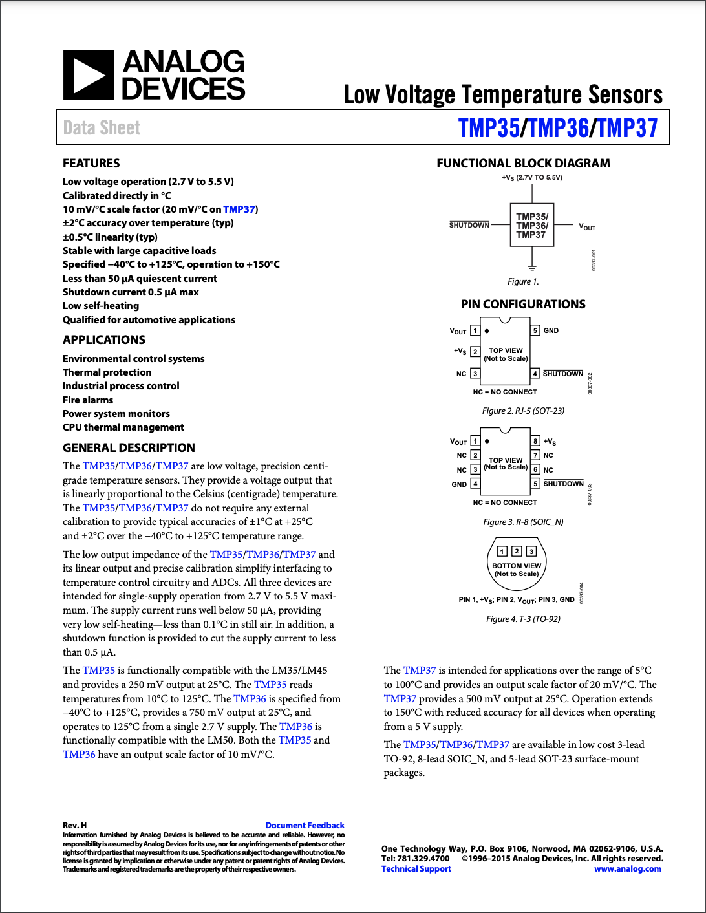

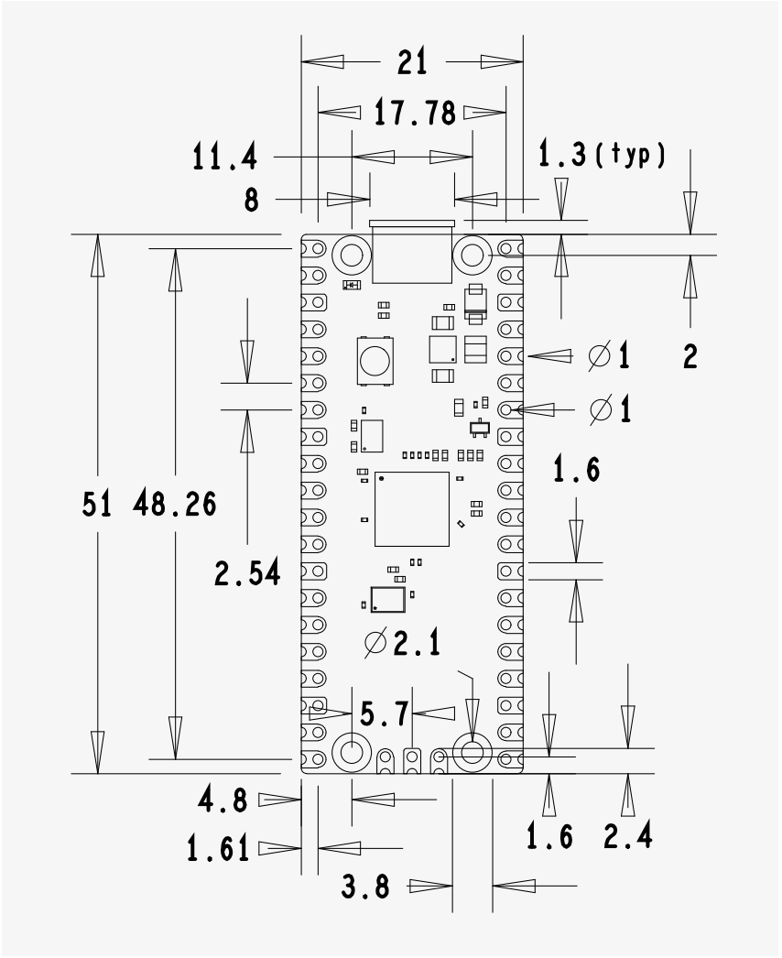

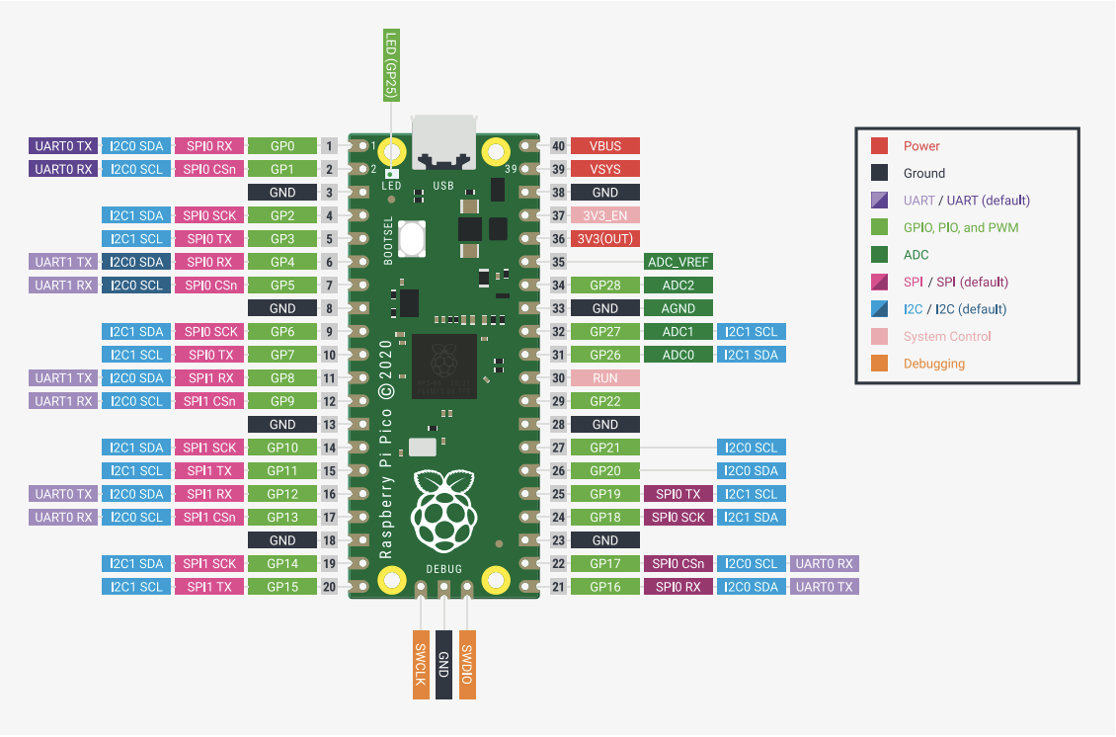
8.4.4 Raspberry Pi Pico Datasheet

8.4.5 Electrical Schematic
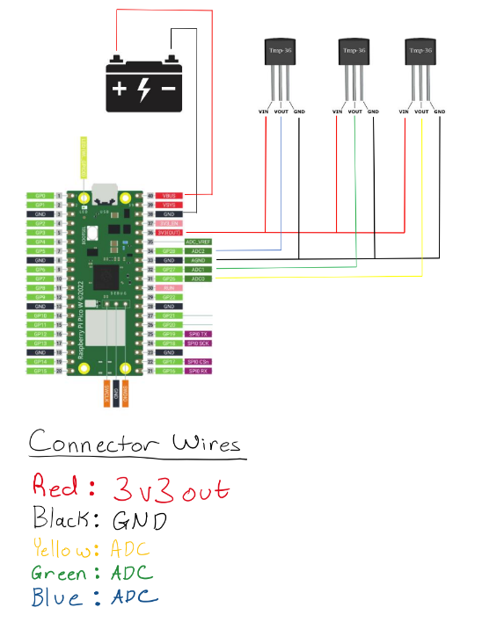

8.4.6 User Manual

https://drive.google.com/file/d/1NOpw8mPWMV5Bo-8thScQWY1SozClZVmt/view?usp=drive_link

